Chapter 13, Problem 31.

Using Fig. 13.100, design a problem to help other students better understand linear transformers and how to find T-equivalent and Π–equivalent circuits.
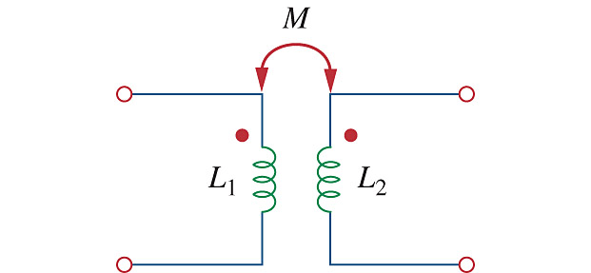

Figure 13.100
For Prob. 13.31.

